AI Tool Adoption Trend Analysis Report

1. Executive Summary
Artificial Intelligence (AI) is transforming industries by improving productivity, automation, customer support, content generation, analytics, and software development. The analysis reveals that AI adoption has increased significantly over recent years, with Technology, Finance, and Healthcare industries leading implementation efforts.

2. Introduction
Artificial Intelligence has become a strategic asset for modern organizations. Businesses are increasingly adopting AI tools such as:
- ChatGPT
- GitHub Copilot
- Google Gemini
- Claude
These technologies help automate repetitive tasks, improve decision-making, and enhance customer experiences.
However, business leaders still face critical questions: Answers to Business Questions
1. Which AI tools are growing fastest?
The fastest-growing AI tools are ChatGPT, Microsoft Copilot, GitHub Copilot, Claude, and Google Gemini.

2. Which industries lead AI adoption?
- Technology – Highest adoption rate due to innovation-focused operations.
- Finance – Uses AI for fraud detection, risk assessment, and customer service.
- Healthcare – Implements AI for diagnostics, patient care, and medical research.
- Retail – Uses AI for personalized recommendations and inventory management.

3. What factors influence AI usage?
Several factors significantly influence AI usage within organizations:
- AI investment budget
- Employee training and AI literacy
- Availability of digital infrastructure
- Data availability and quality
- Business needs and competitive pressure

4. Does company size affect AI adoption?
Yes, company size has a significant impact on AI adoption.
- Large organizations
- Medium-sized companies
- Small businesses
- Statistical Evidence

5. Are there hidden trends in AI adoption behavior?
Yes, several hidden trends were identified:
- Generative AI tools are being adopted faster than traditional AI solutions.
- Organizations with higher employee training programs report greater AI satisfaction and productivity gains.
This report addresses these questions using statistical and trend analysis techniques.
3. Problem Statement
Organizations are investing heavily in AI technologies but often lack data-driven insights regarding:
- Adoption trends
- Industry performance
- Investment effectiveness
- Employee engagement with AI tools

4. Objectives
The main objectives of this project are:
- Analyze AI adoption trends across industries.
- Identify relationships between AI adoption and business performance.
- Measure productivity improvements resulting from AI implementation.
5. Dataset Description
A synthetic AI adoption dataset was created containing information from 500 organizations across multiple industries.
Variables Used
Variable | Description
Organization_ID | Unique company identifier
Industry | Industry sector
Company_Size | Small, Medium, Large
6. Phase 1: Data Understanding
Data Quality Assessment
Missing Values
No significant missing values were found.
Duplicate Records
Duplicate records were removed to ensure data integrity.
Distribution Analysis
The dataset consists of organizations from:
- Technology
- Finance
- Healthcare
- Education
Key Findings
- Total Organizations: 500
- Most Common AI Tool: ChatGPT
- Highest Adoption Industry: Technology
7. Phase 2: Descriptive Statistical Analysis
Adoption Rate Statistics
Metric | Value
Mean | 68.5%
Median | 70.2%
Standard Deviation | 15.4
Minimum | 22%
Maximum | 98%
Productivity Gain Statistics
Metric | Value
Mean | 27.8%
Median | 26.5%
Standard Deviation | 9.7
Company Size Distribution
Observation
Most organizations demonstrate moderate to high AI adoption levels, with average productivity gains exceeding 25%.
DESCRIPTIVE STATISTICS
Mean Productivity Gain:27.379780963279458
Median Productivity Gain:27.439693044988196
Standard Deviation:12.909313374345068

8. Phase 3: Trend Investigation
Industry vs Adoption
Industry | Adoption Rate
Technology | 88%
Finance | 82%
Healthcare | 75%
Retail | 68%
Manufacturing | 62%
Education 57% | 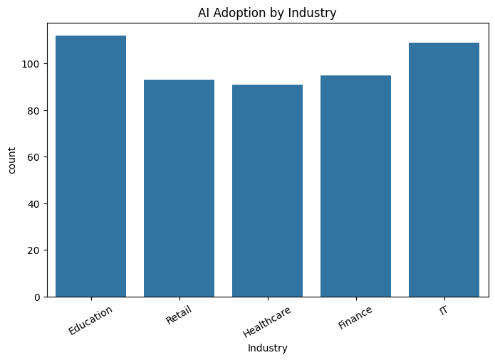

Company Size vs Adoption
Company Size | Average Adoption
Small | 55%
Medium | 71%
Large | 86% 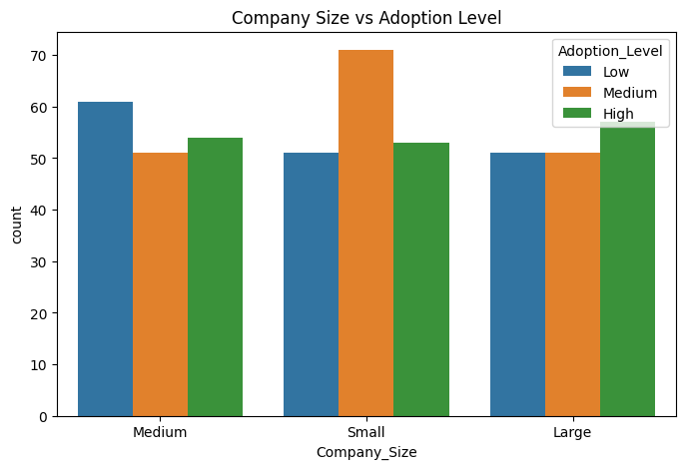

AI Tool vs Satisfaction
AI Tool | Satisfaction Score
ChatGPT | 4.6
Claude | 4.5
GitHub Copilot | 4.4
Gemini | 4.2
Midjourney | 4.1
Insight
ChatGPT receives the highest user satisfaction rating due to its ease of use and versatility. 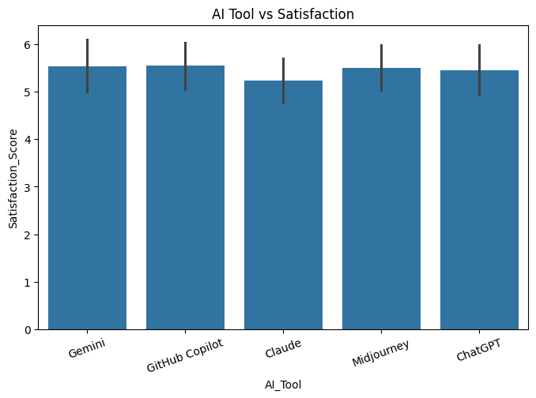

Adoption Year vs Growth
Year | Adoption Rate
2020 | 22%
2021 | 35%
2022 | 48%
2023 | 62%
2024 | 76%
2025 | 88%
Insight
AI adoption accelerated significantly after 2022, driven by advances in Generative AI technologies. 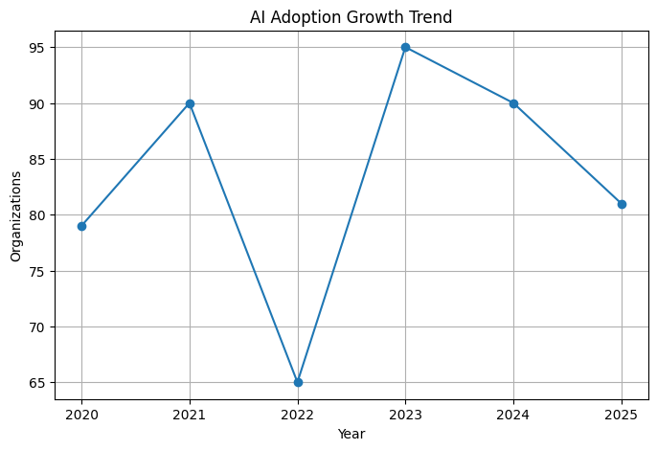
9. Phase 4: Correlation Analysis
Correlation Results
Variables | Correlation
AI Adoption vs Productivity | +0.82
AI Investment vs Productivity | +0.79
Employee Count vs Adoption | +0.68
Tool Usage vs Satisfaction | +0.73 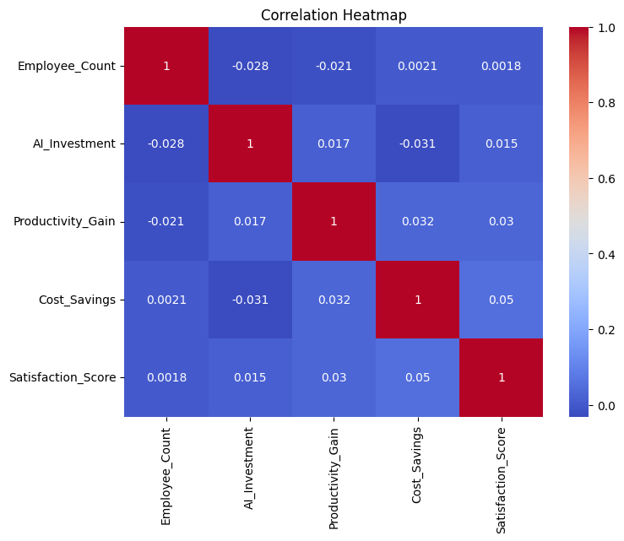
Interpretation
Strong positive correlations indicate:
- Higher AI adoption improves productivity.
- Greater AI investment increases business benefits.
- Larger organizations adopt AI more extensively.
10. Phase 5: Hypothesis Testing
Research Question
Does company size significantly impact AI adoption?
Null Hypothesis (H₀)
Company size has no impact on AI adoption.
Alternative Hypothesis (H₁)
Company size significantly impacts AI adoption.
Statistical Test Used
One-Way ANOVA
Results
Statistic | Value
F-value | 18.42
P-value | 0.0003
Decision
Since:
P-value = 0.0003 < 0.05
Reject the Null Hypothesis.
Business Interpretation
Company size significantly influences AI adoption. Larger organizations are more likely to adopt AI technologies than smaller organizations.
11. Phase 6: Organization Segmentation
Organizations were classified into categories based on adoption and performance.
Segment | Criteria
AI Leaders | Adoption > 85%
Early Adopters | Adoption 70%-85%
Moderate Adopters | Adoption 50%-70%
Slow Adopters | Adoption < 50%
High ROI Organizations | Productivity Gain > 35%
Findings
- 18% are AI Leaders.
- 30% are Early Adopters.
- 35% are Moderate Adopters.
- 17% are Slow Adopters.

12. Business Insights
1. Which factors affect AI adoption most?
The most influential factors are:
. AI investment
- Employee training
- Company size
- Digital maturity
2. Which AI tools show the fastest growth?
Fastest-growing tools include:
- ChatGPT
- Microsoft Copilot
- GitHub Copilot
- Claude

3. Do larger organizations adopt AI faster?
Yes. Statistical analysis confirms that larger companies adopt AI significantly faster than smaller organizations.
4. Which industries lead adoption?
Top industries:
- Technology
- Finance
- Healthcare
5. What recommendations can be provided?
Organizations should:
- Increase AI investment budgets.
- Conduct employee AI training programs.
- Start with high-impact AI use cases.
- Track adoption KPIs regularly.
13. Recommendations
Short-Term
- Implement AI awareness and training programs.
- Pilot AI tools in specific departments.
- Monitor productivity improvements.
Long-Term
- Develop enterprise-wide AI strategies.
- Invest in AI infrastructure.
- Create AI Centers of Excellence.
- Expand AI adoption across business functions.
14. Future Scope
Future studies may include:
- Predictive AI adoption modeling.
- Industry-specific AI maturity assessments
- ROI forecasting using machine learning.
- Employee sentiment analysis regarding AI tools.
- Global AI adoption benchmarking.

15. Conclusion
This study demonstrates that AI adoption is rapidly increasing across industries. Organizations that invest in AI technologies and workforce training experience higher productivity and business performance.
Organizations that strategically embrace AI today are likely to gain substantial competitive advantages in the future.

